1. **Fruits**

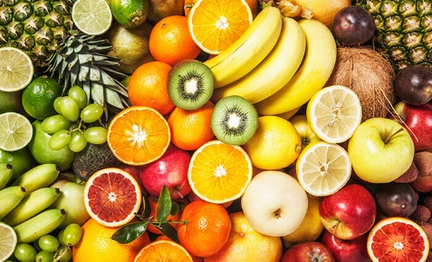

|  |
| --- |
| **Fruits** |
| * colour: String * fragrance: Boolean * main components: String * appearance: String |
| * getColour() : String * isFragrant(Boolean fragrant): void * mainComponents(String component): void * appearanceOfFruit(appearance : string) : void |

|  |
| --- |
| **Banana** |
| * colour: String * fragrance: Boolean * main components: String * appearance: String |
| * getColour() : String * isFragrant(Boolean fragrant): void * mainComponents(String component): void * appearanceOfFruit(appearance : string) : void |

|  |
| --- |
| **Apple** |
| * colour: String * fragrance: Boolean * main components: String * appearance: String |
| * getColour() : String * isFragrant(Boolean fragrant): void * mainComponents(String component): void * appearanceOfFruit(appearance : string) : void |

|  |
| --- |
| **Pineapple** |
| * colour: String * fragrance: Boolean * main components: String * appearance: String |
| * getColour() : String * isFragrant(Boolean fragrant): void * mainComponents(String component): void * appearanceOfFruit(appearance : string) : void |

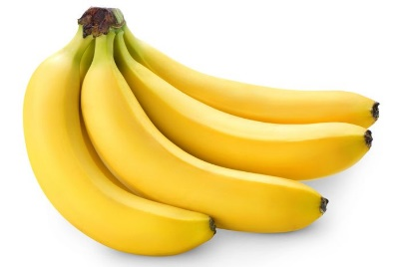

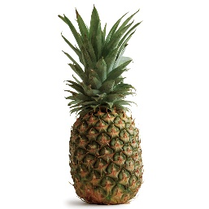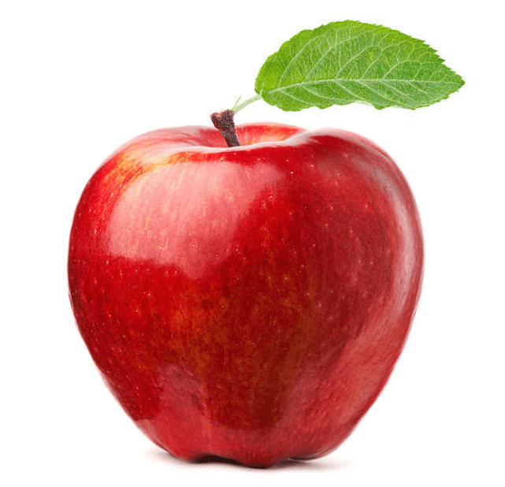

1. **Vegetables**

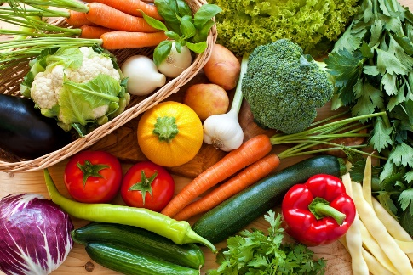

|  |
| --- |
| **Vegetables** |
| * colour: String * main components: String * appearance: String |
| * reduceRiskHealthDisease(): void * providesEssentialMinerals(): void * preventConstipation(): void * providesHealthBenefits(): void |

|  |
| --- |
| **Tomato** |
| * colour: String * main components: String * appearance: String |
| * reduceRiskHealthDisease(): void * providesEssentialMinerals(): void * preventConstipation(): void * providesHealthBenefits(): void |

|  |
| --- |
| **Carrot** |
| * colour: String * main components: String * appearance: String |
| * reduceRiskHealthDisease(): void * providesEssentialMinerals(): void * preventConstipation(): void * providesHealthBenefits(): void |

|  |
| --- |
| **Onion** |
| * colour: String * main components: String * appearance: String |
| * reduceRiskHealthDisease(): void * providesEssentialMinerals(): void * preventConstipation(): void * providesHealthBenefits(): void |

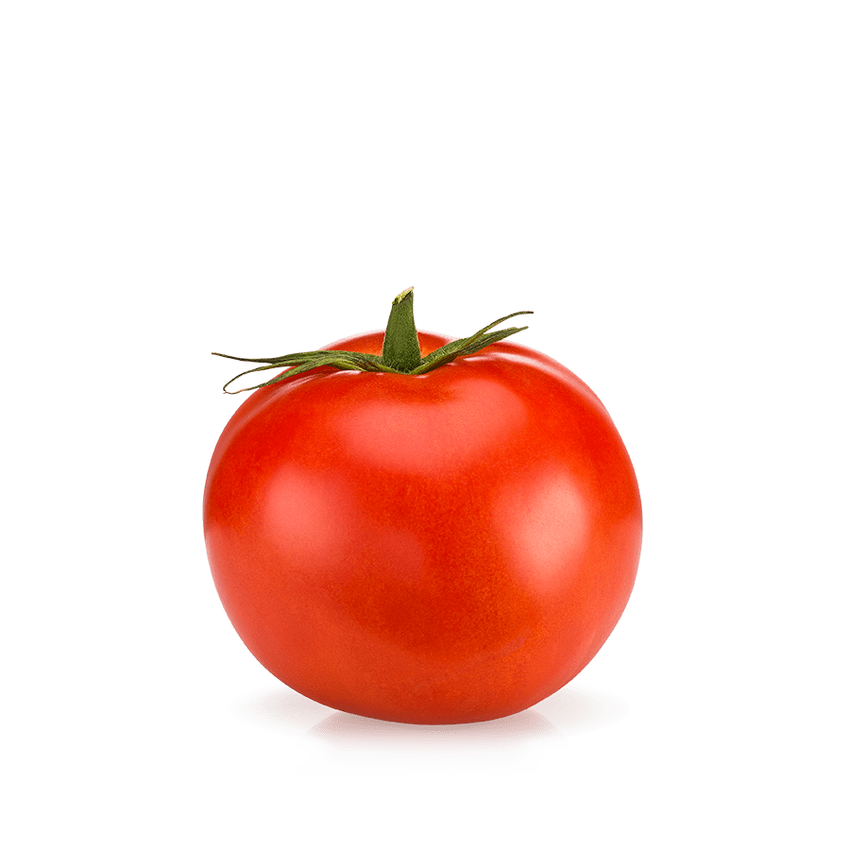

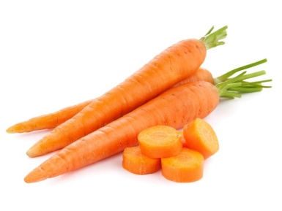

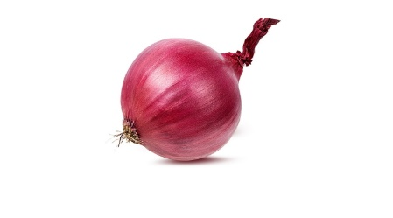

1. **Meats**

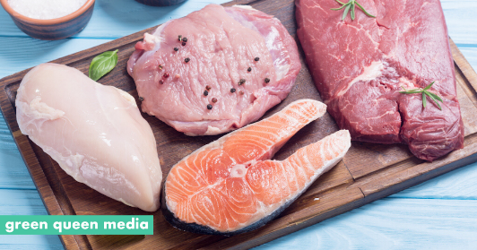

|  |
| --- |
| **Meats** |
| * flavour: string * tenderness: string * juiciness: boolean |
| * providesProtein(): void * processIntoFoodItems(canProcess : char) : void * canBeCooked() : string |

|  |
| --- |
| **Fish** |
| * flavour: string * tenderness: string * juiciness: boolean |
| * providesProtein(): void * processIntoFoodItems(canProcess : char) : void * canBeCooked() : string |

|  |
| --- |
| **Red meat** |
| * flavour: string * tenderness: string * juiciness: boolean |
| * providesProtein(): void * processIntoFoodItems(canProcess : char) : void * canBeCooked() : string |

|  |
| --- |
| **Seafood** |
| * flavour: string * tenderness: string * juiciness: boolean |
| * providesProtein(): void * processIntoFoodItems(canProcess : char) : void * canBeCooked() : string |

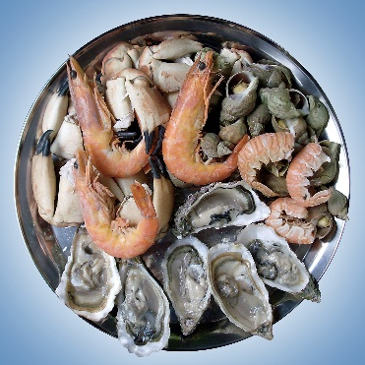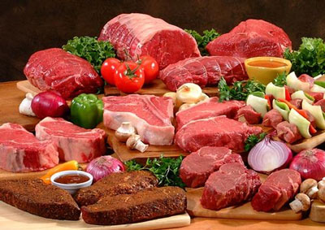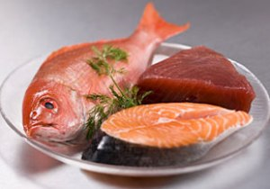

1. **Drinks**

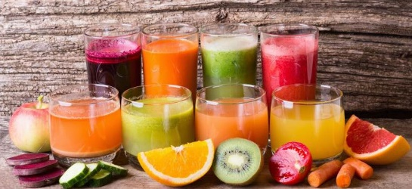

|  |
| --- |
| **Drinks** |
| * plain: Boolean * alcoholic: Boolean * carbonated: Boolean |
| * satisfyThristy (canSatisfy): Boolean * feelRefreshed(): char * washFoodDown(): void |

|  |
| --- |
| **Water** |
| * plain: Boolean * alcoholic: Boolean * carbonated: Boolean |
| * satisfyThristy (canSatisfy): Boolean * feelRefreshed(): void * washFoodDown(): void |

|  |
| --- |
| **Soft drinks** |
| * plain: Boolean * alcoholic: Boolean * carbonated: Boolean |
| * satisfyThristy (canSatisfy): Boolean * feelRefreshed(): void * washFoodDown(): void |

|  |
| --- |
| **coffee** |
| * plain: Boolean * alcoholic: Boolean * carbonated: Boolean |
| * satisfyThristy (canSatisfy): Boolean * feelRefreshed(): void * washFoodDown(): void |

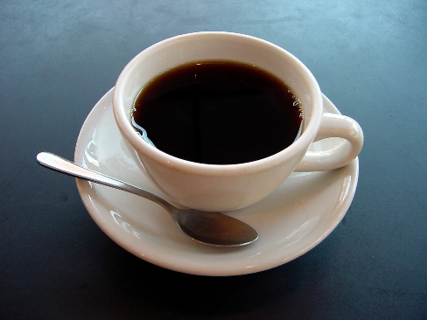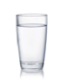



1. **Cooking oil**

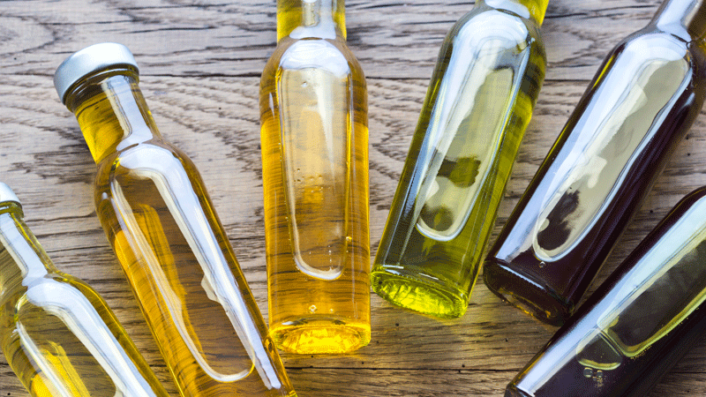

|  |
| --- |
| **Cooking Oil** |
| * boiling point: float * smoking point: float * density: double |
| * dressing(): void * roosting(): void * frying(): void * baking(): void |

|  |
| --- |
| **Olive oil** |
| * boiling point: float * smoking point: float * density: double |
| * dressing(): void * roosting(): void * frying(): void * baking(): void |

|  |
| --- |
| **Sunflower oil** |
| * boiling point: float * smoking point: float * density: double |
| * dressing(): void * roosting(): void * frying(): void * baking(): void |

|  |
| --- |
| **Coconut oil** |
| * boiling point: float * smoking point: float * density: double |
| * dressing(): void * roosting(): void * frying(): void * baking(): void |

